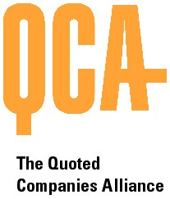

THE QUOTED COMPANIES ALLIANCE
CORPORATE GOVERNANCE COMMITTEE
PROPOSED MEETING DATES FOR 2012

All at 4.30pm unless otherwise advised.

Monday 16 January 2012

Monday 19 March 2012

Monday 14 May 2012

Monday 16 July 2012

Monday 17 September 2012

Monday 12 November 2012

